**Chapter 7**

# **Bootstrap Navbar**

## **What is a Navbar?**

A **navbar** (navigation bar) in Bootstrap is a responsive header component that contains links, dropdowns, logos, and forms. It helps users navigate the website easily and adapts automatically to mobile screens.

## **Why Do We Add a Navbar?**

* Provides clear navigation
* Works on all screen sizes
* Supports brand/logo section
* Improves website structure and user experience

Bootstrap gives you **responsive navbars** that automatically collapse into a hamburger menu on smaller screens.

| **Class** | **Navbar expands (shows full menu) at** | **Collapses (hamburger) at** |
| --- | --- | --- |
| navbar-expand-sm | ≥ 576px | < 576px |
| navbar-expand-md | ≥ 768px | < 768px |
| navbar-expand-lg | ≥ 992px | < 992px |
| navbar-expand-xl | ≥ 1200px | < 1200px |
| navbar-expand-xxl | ≥ 1400px | < 1400px |
| navbar-expand | Always expanded (never collapses) | Never collapses |

## **Example**: **Collapsible Navbar With Dropdown**

<nav class="navbar **navbar-expand-lg** bg-dark **navbar-dark**">

<div class="container-fluid">

**<a class="navbar-brand" href="#">**

**<img src="n.png" alt="Logo" width="30" height="24" class="d-inline-block rounded-circle"> My Website**

**</a>**

**<button class="navbar-toggler" type="button" data-bs-toggle="collapse" data-bs-target="#navbarSupportedContent">**

      <span class="navbar-toggler-icon"></span>

**</button>**

**<div class="collapse navbar-collapse" id="navbarSupportedContent">**

      <ul class="navbar-nav ms-auto mb-2">

        <li class="nav-item">

          <a class="nav-link active" href="#">Home</a>

        </li>

        <li class="nav-item">

          <a class="nav-link" href="#">About</a>

        </li>

**<!—Dropdown -->**

<li class="nav-item dropdown">

          <a class="nav-link dropdown-toggle" href="#" data-bs-toggle="dropdown" >

            Projects

          </a>

          <ul class="dropdown-menu">

            <li><a class="dropdown-item" href="#">Staff</a></li>

            <li><a class="dropdown-item" href="#">Company</a></li>

            <li><hr class="dropdown-divider"></li>

            <li><a class="dropdown-item" href="#">Services</a></li>

          </ul>

        </li>

        <li class="nav-item">

          <a class="nav-link disabled">Contact</a>

        </li>

      </ul>

**</div>**

  </div>

</nav>

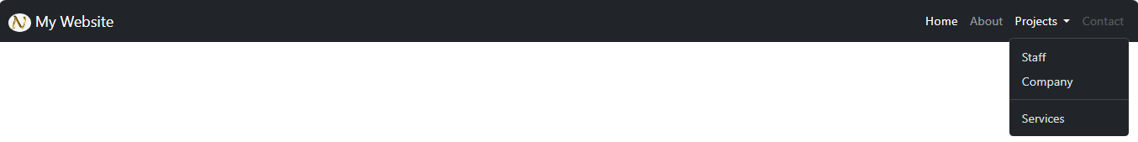

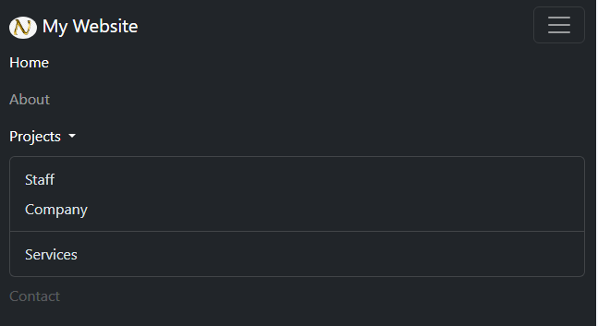

| **Class / Attribute** | **Meaning / Function** |
| --- | --- |
| **navbar** | Enables Bootstrap navbar component styling |
| **navbar-expand-lg** | Navbar expands on large screens and collapses on smaller screens |
| **bg-dark** | Applies a dark background color |
| **navbar-dark** | navbar-dark is a Bootstrap class used on a navbar to make the **text, links, and toggler button turn light-colored** (usually white). It is meant to be used when the navbar has a **dark background**. |
| **container-fluid** | Full-width responsive container |
| **navbar-brand** | Styles website logo/title area |
| **d-inline-block** | Displays logo image inline with text |
| **rounded-circle** | Makes the image perfectly circular |
| **navbar-toggler** | Creates the mobile “hamburger” button |
| **data-bs-toggle="collapse"** | Tells the button to open/close collapsible menu |
| **data-bs-target="#navbarSupportedContent"** | Connects button to the collapsible menu div |
| **navbar-toggler-icon** | Default Bootstrap hamburger icon |
| **collapse** | Makes the menu collapsible on small screens |
| **navbar-collapse** | Ensures collapse is styled correctly for navbars |
| **navbar-nav** | Styles <ul> as a horizontal navbar menu |
| **ms-auto** | Pushes nav items to the right side |
| **mb-2** | Margin-bottom on small screens; |
| **nav-item** | Styles each list item inside navbar |
| **nav-link** | Styles hyperlinks inside navbar |
| **active** | Highlights the current page link |
| **dropdown** | Enables dropdown behavior |
| **dropdown-toggle** | Turns link into dropdown trigger |
| **data-bs-toggle="dropdown"** | Enables dropdown toggle functionality |
| **dropdown-menu** | Container for dropdown items |
| **dropdown-item** | Styles individual dropdown links |
| **dropdown-divider** | Horizontal line separator inside dropdown |
| **disabled** | Disables a nav link (unclickable) |

## **Difference ms-auto and me-auto**

| **Class** | **Does What?** | **Effect** |
| --- | --- | --- |
| **ms-auto** | Applies margin-left: auto | Pushes **this** element to the **right** |
| **me-auto** | Applies margin-right: auto | Pushes **next elements** to the **right** |

In above example we have added ms-auto.

      <ul class="navbar-nav **ms-auto** mb-2">

      </ul>

Replace it with **me-auto** and you will get the below output.

## 

## **Fixed Navigation Bar**

* The navigation bar can also be fixed at the top or at the bottom of the page.
* A fixed navigation bar stays visible in a fixed position (top or bottom) independent of the page scroll.
* The .fixed-top class makes the navigation bar fixed at the **top**:

<nav class="navbar navbar-expand-sm bg-dark **fixed-top**"></nav>

Use the .fixed-bottom class to make the navbar stay at the **bottom** of the page:

<nav class="navbar navbar-expand-sm bg-dark **fixed-bottom**"> </nav>

Use the .sticky-top class to make the navbar fixed/stay at the **top** of the page when you scroll **past** it.

**Note:**This class does not work in IE11 and earlier (will treat it as position:relative).

<nav class="navbar navbar-expand-sm bg-dark **sticky-top**"></nav>

**Scrollspy**

* **Scrollspy** highlights the current section’s link in the navigation while you scroll.
* Use it when your page has multiple sections and you want the menu to show where the user is on the page.

<!DOCTYPE html>

<html lang="en">

<head>

  <meta charset="UTF-8">

  <meta name="viewport" content="width=device-width, initial-scale=1">

  <title>Bootstrap 5.3.8 Dropdown Demo</title>

  <link href="https://cdn.jsdelivr.net/npm/bootstrap@5.3.8/dist/css/bootstrap.min.css" rel="stylesheet">

</head>

<body style="padding-top:70px ;">

**<nav class="navbar navbar-expand-lg bg-dark fixed-top" id="scrollpage">**

        <div class="container-fluid">

            <ul class="navbar-nav nav-pills m-2">

                <li class="nav-item ">

                <a class="nav-link active text-white" **href="#section1"**>Home</a>

                </li>

                <li class="nav-item">

                <a class="nav-link text-white" **href="#section2"**>About</a>

                </li>

                <li class="nav-item">

                <a **href="#section3"** class="nav-link text-white">Contact</a>

                </li>

            </ul>

        </div>

**</nav>**

    <div **data-bs-spy="scroll"** **data-bs-target="#scrollpage"**>

<div **id="section1"** class="container-fluid bg-success text-white" style="height:800px; padding: 100px;">

        <h1>Welcome to Home Section</h1>

        <p>Enjoy scrolling</p>

        </div>

        <div **id="section2"** class="container-fluid bg-warning text-white" style="height:800px;padding: 100px;">

        <h1>Welcome to About Section</h1>

        <p>Enjoy scrolling</p>

        </div>

        <div **id="section3"** class="container-fluid bg-info text-white" style="height:800px;padding: 100px;">

        <h1>Welcome to Contact Section</h1>

        <p>Enjoy scrolling</p>

        </div>

    </div>

<script src="https://cdn.jsdelivr.net/npm/bootstrap@5.3.8/dist/js/bootstrap.bundle.min.js"></script>

</body>

</html>

| **Code / Class / Attribute** | **Meaning / Purpose** |
| --- | --- |
| <nav class="navbar navbar-expand-lg bg-dark fixed-top" id="scrollpage"> | Creates a dark navbar that stays fixed at the top. id="scrollpage" allows Scrollspy to update this navbar. |
| navbar | Bootstrap navigation bar component. |
| navbar-expand-lg | Navbar expands on large screens; collapses on smaller ones. |
| bg-dark | Sets the navbar background to dark. |
| fixed-top | Navbar stays at the top during scroll. |
| id="scrollpage" | Scrollspy uses this navbar to highlight active links. |
| <ul class="navbar-nav nav-pills m-2"> | Container for navigation links. |
| navbar-nav | Styles list items as navbar links. |
| **nav-pills** | **Enables Bootstrap's built-in active link highlighting (blue active tab). Needed to make active link visible.** |
| m-2 | Adds margin. |
| <a class="nav-link text-white" href="#section1"> | Each link points to a section ID. Scrollspy will highlight these. |
| nav-link | Styles the anchor as a Bootstrap navigation link. |
| text-white | Makes link text white. |
| active | Indicates the starting active link (Home). Scrollspy updates this dynamically. |
| <div data-bs-spy="scroll"> | Activates Scrollspy functionality. |
| data-bs-target="#scrollpage" | Tells Scrollspy which navbar to update. |
| bg-success / bg-warning / bg-info | Background colors for each section. |
| <div id="section1"> | Section anchor. Must match navbar link (href="#section1"). |

### nav-pills is added so that the ****active link becomes visible automatically****

Without nav-pills, Bootstrap does **not apply any active background color**, so Scrollspy works but you won’t see the active link change.

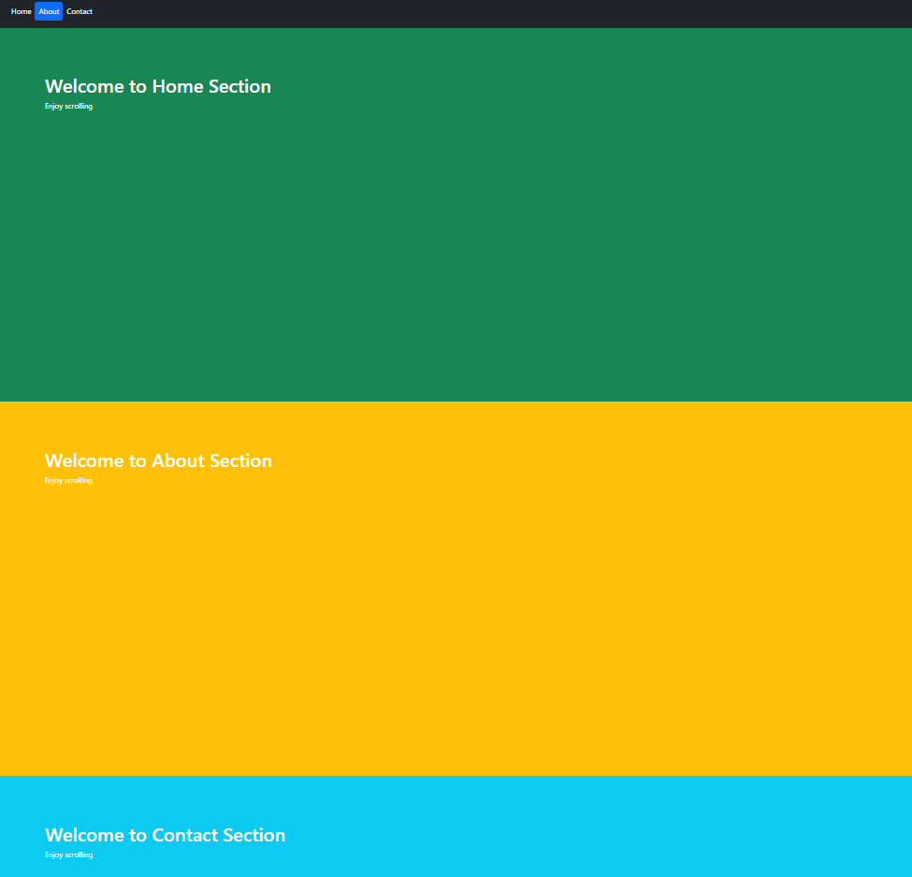

**Pagination**

Pagination divides **large content into multiple pages**, making it easier to view and faster to load.  
It helps users move to the **next, previous, or specific page** without overwhelming the screen.

### ****Why use pagination?****

* Shows content in **small, manageable parts**
* **Improves performance** (loads fewer items at a time)
* Makes navigation **easy and organized**
* Prevents very long, cluttered pages

# **Pagination Classes**

| **Class** | **Where Used** | **Meaning / Purpose** |
| --- | --- | --- |
| pagination | <ul> | Main Bootstrap pagination component container. |
| page-item | <li> | Wrapper for each pagination item/button. |
| page-link | <a> | The clickable pagination link/button. |
| active | <li> | Indicates the current/selected page. |
| disabled | <li> | Disables a link (not clickable). |

**Example:**

<nav>

  <ul class="pagination">

    <li class="page-item disabled">

      <a class="page-link">Previous</a>

    </li>

    <li class="page-item"><a class="page-link" href="#">1</a></li>

    <li class="page-item active">

      <a class="page-link" href="#">2</a>

    </li>

    <li class="page-item"><a class="page-link" href="#">3</a></li>

    <li class="page-item">

      <a class="page-link" href="#">Next</a>

    </li>

  </ul>

</nav>



# **Additional Pagination Alignment Classes**

Use these **on the <ul class="pagination"> container**:

| **Class** | **Effect** |
| --- | --- |
| justify-content-start | Align pagination **left** (default). |
| justify-content-center | Center the pagination. |
| justify-content-end | Align pagination **right**. |

**Example:**

<ul class="pagination justify-content-center">

# **Pagination Sizing Classes**

Add these **to the <ul class="pagination">** to change button size:

| **Class** | **Size** |
| --- | --- |
| pagination-lg | Large pagination buttons |
| pagination-sm | Small pagination buttons |
| (no class) | Default size |

**Example:**

<ul class="pagination pagination-lg">

# **Carousel**

A **carousel** is a slideshow component that allows rotating images, text, or custom content.

### Purpose of a Carousel

* Display multiple images or slides in limited space
* Add visual appeal to a website
* Highlight important content (banners, promotions, events)
* Provide automatic or manual slide controls
* Works on all screen sizes
* Includes indicators, captions, previous/next navigation

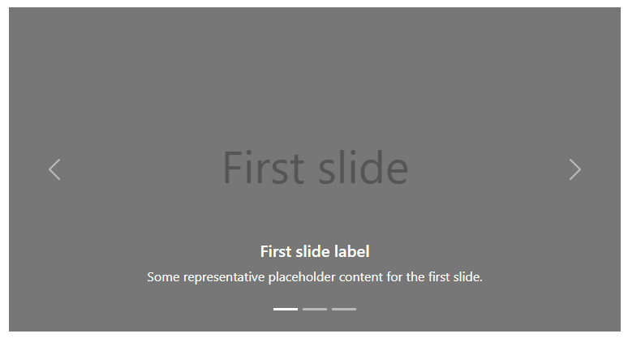

**Example**

**<!-- Root carousel element: unique id used by controls/indicators -->**

<div **id="carouselExampleCaptions"** class="carousel slide" **data-bs-ride="carousel" data-bs-pause="hover"**>

**<!-- Indicators (small buttons that jump to a specific slide) -->**

  <div class="carousel-indicators">

**<!--**

**data-bs-target must match the carousel id.**

**data-bs-slide-to is the zero-based slide index.**

**'active' marks the initial visible indicator.**

**-->**

    <button **data-bs-target="#carouselExampleCaptions"** **data-bs-slide-to="0"** class="active"></button>

    <button **data-bs-target="#carouselExampleCaptions"** **data-bs-slide-to="1"**></button>

    <button type="button" **data-bs-target="#carouselExampleCaptions"** **data-bs-slide-to="2"**></button>

  </div>

**<!-- Container for the slides -->**

  <div class="carousel-inner">

**<!-- Each .carousel-item is one slide.**

**Add .active to one item so the carousel shows something initially.**

**data-bs-interval on a slide overrides the global interval for that slide. -->**

    <div class="carousel-item **active**" **data-bs-interval="1000"**>

**<!-- .d-block makes the image display:block; .w-100 makes it full width of the carousel.**

**h-75 is a utility that sets height: 75% (use cautiously — better to control image aspect with CSS). -->**

      <img src="1.jpg" class="d-block w-100 h-75" alt="First slide image description">

**<!-- Caption area (positioned over the image). Use for headings/short descriptions. -->**

<div class="carousel-caption">

        <h5>First slide label</h5>

        <p>Some representative placeholder content for the first slide.</p>

         <a href="#" class="btn btn-danger">View all</a>

      </div>

    </div>

**<!—second carousel-item -->**

    <div class="carousel-item" **data-bs-interval="10000"**>

      <img src="1.jpg" class="d-block w-100" alt="Second slide image description">

 <div class="carousel-caption bg-warning text-dark w-25 mx-auto">

        <h5>Second slide label</h5>

        <p>Some representative placeholder content for the second slide.</p>

         <a href="#" class="btn btn-danger">View all</a>

      </div>

    </div>

**<!—third carousel-item -->**

    <div class="carousel-item">

      <img src="1.jpg" class="d-block w-100" alt="Third slide image description">

      <!-- You added bg-dark on caption — that places a dark background behind caption text. -->

<div class="carousel-caption bg-dark">

        <h5>Third slide label</h5>

        <p>Some representative placeholder content for the third slide.</p>

        <a href="#" class="btn btn-danger">View all</a>

      </div>

    </div>

  </div>

**<!-- Prev control: moves to previous slide -->**

  <button class="carousel-control-prev" **data-bs-target="#carouselExampleCaptions"** **data-bs-slide="prev"**>

**<!-- The inner span is the visual icon. aria-hidden or visually-hidden are for accessibility. -->**

    <span class="carousel-control-prev-icon"></span>

  </button>

**<!-- Next control: moves to next slide -->**

  <button class="carousel-control-next" data-bs-target="#carouselExampleCaptions" **data-bs-slide="next"**>

    <span class="carousel-control-next-icon" ></span>

  </button>

</div>

**First slide output**

**Second slide output** 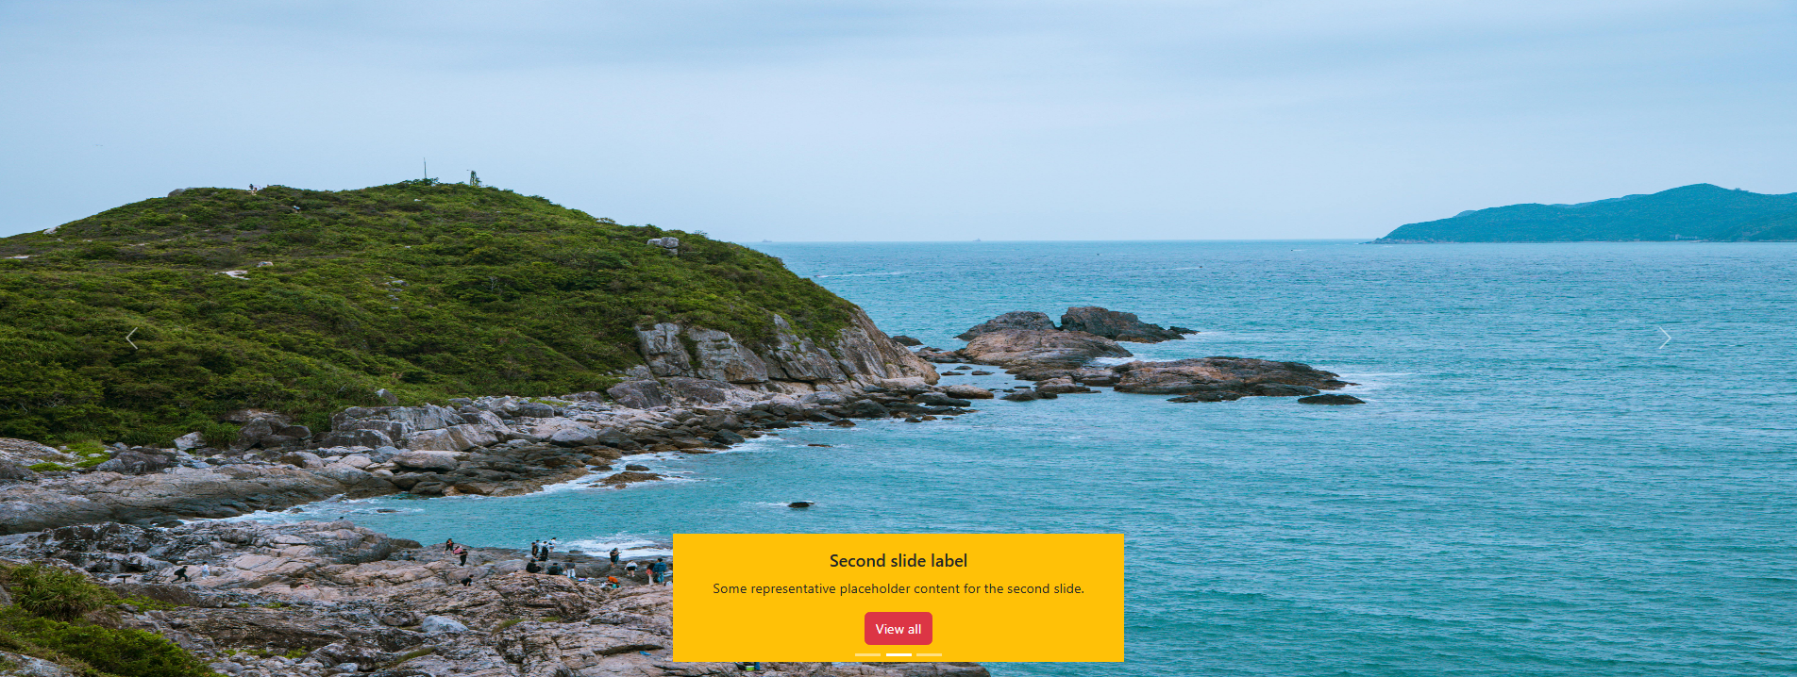

**Third slide output** 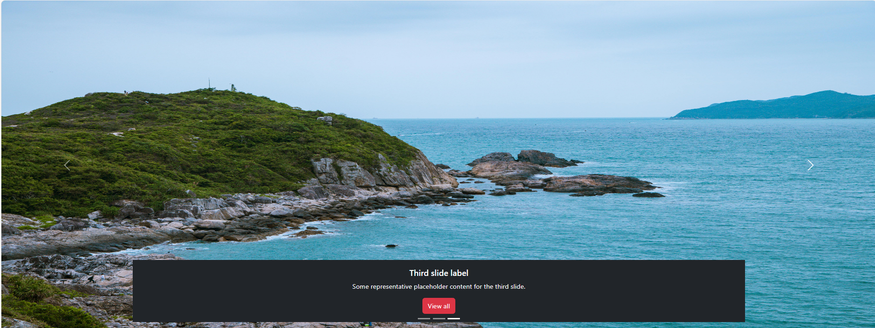

**Classes and Attributes**

| **Item** | **Meaning / Effect** | **Possible values / notes** |
| --- | --- | --- |
| id="carouselExampleCaptions" | Unique identifier used by indicators/controls to target this carousel | Any unique id; required to link controls/indicators |
| class="carousel" | Base Bootstrap carousel styling | required for component |
| class="slide" | Enables sliding animation (CSS/JS) | omit to disable slide animation |
| data-bs-ride="carousel" | Autostart the carousel on page load (autoplay) | omit if you want manual init; alternative: initialize via JS new bootstrap.Carousel |
| data-bs-pause="hover" | Now, when the mouse is over the carousel, it stops sliding. | hover |
| .carousel-indicators | Wrapper for indicator buttons (small dots) | optional . you can omit indicators |
| button data-bs-slide-to="n" | Jump to slide n (0-based) | n = 0,1,2,... must match number of slides |
| class="active" on indicator/item | Marks initial visible slide/indicator | Only on one slide/indicator |
| .carousel-inner | Slide container | required |
| .carousel-item | One slide wrapper | required for each slide |
| data-bs-interval="ms" on .carousel-item | Per-slide duration in milliseconds | e.g. 1000, 10000;  overrides global interval 5000 ms(default). |
| <img class="d-block w-100"> | d-block (display:block); w-100 (width:100%) | Replace w-100 with custom sizing or use object-fit for cropping |
| .carousel-caption | Positions caption area (bottom-center by default) | You can add text-start or text-end, or custom classes |
| .carousel-control-prev / .carousel-control-next | Prev/next control wrappers | Buttons recommended; can use <a> with role="button" |
| data-bs-target="#id" on controls | Targets the carousel id | Must match carousel id |
| data-bs-slide="prev" / "next" | Tells control direction | Only prev or next |
| .carousel-control-*-icon | Built-in icon visuals (uses background-image) | You can replace with custom icons (SVG/font icon) |

* **One slide must have .active** — otherwise carousel is invisible initially.
* **Unique id**: indicators & controls must use data-bs-target matching the carousel id.
* **Autoplay**: data-bs-ride="carousel" will initialize automatically; if absent, call new bootstrap.Carousel(myEl) to enable touch/swipe events. Don’t double-initialize.
* **Per-slide timing**: data-bs-interval on .carousel-item overrides the global interval for that slide.
* **Accessibility**: include alt text on images, and consider pause-on-hover or a visible pause button
* **Do not nest carousels** — nested carousels are unsupported.

**Modal**

* A **modal** is a popup window that appears on top of a webpage.  
  It is used to show important information or interact with the user **without leaving the current page**.
* When a modal opens, the rest of the page becomes inactive until the modal is closed.  
  This helps the user focus on a specific task such as filling a form, confirming an action, or viewing additional details.

### ****Why Modals Are Used****

* To display important messages or alerts
* To show forms (login, signup, feedback)
* To confirm actions (delete, submit, save)
* To display extra information (images, details) without switching pages
* To keep the user in the same location while interacting with content

## **Modal Container Classes**

| **Class** | **Purpose** |
| --- | --- |
| modal | Base class for modal |
| fade | Adds fade-in animation |

## **Modal Dialog Classes**

| **Class** | **Purpose** |
| --- | --- |
| **modal-dialog** | Main wrapper for dialog box |
| **modal-sm** | Small modal (≈300px) |
| **modal-lg** | Large modal (≈800px) |
| **modal-xl** | Extra-large modal (≈1140px) |
| **modal-fullscreen** | Fullscreen modal on all sizes |
| **modal-dialog-centered** | Vertically centers the modal |
| **modal-dialog-scrollable** | Makes body scrollable; header/footer fixed |

## **Modal Content Structure**

| **Class** | **Purpose** |
| --- | --- |
| modal-content | Wraps the entire content inside dialog |
| modal-header | Header section (title + close button) |
| modal-title | Title style |
| modal-body | Main content area |
| modal-footer | Footer (buttons like Save / Close) |

## **Modal Triggers**

| **Attribute** | **Purpose** |
| --- | --- |
| data-bs-toggle="modal" | Opens a modal |
| data-bs-target="#id" | Specifies which modal to open |
| data-bs-dismiss="modal" | Closes the modal (used in buttons) |

**Example:**

**<!-- Button trigger modal -->**

<button class="btn btn-primary" **data-bs-toggle="modal"** **data-bs-target="#exampleModal"**>

  Launch demo modal

</button>

**<!-- Modal -->**

<div class="modal fade " **id="exampleModal"** >

  <div class="modal-dialog">

    <div class="modal-content">

      <div class="modal-header">

        <h1 class="modal-title fs-5" id="exampleModalLabel">Modal title</h1>

        <button type="button" class="btn-close" **data-bs-dismiss="modal"** ></button>

      </div>

      <div class="modal-body ">

       Lorem ipsum dolor sit amet consectetur adipisicing elit. Ratione reiciendis, perspiciatis quaerat tenetur rem placeat? Velit mollitia reiciendis officiis sunt asperiores? Alias, cumque tempora! A corrupti mollitia ad perferendis nobis.

        Lorem ipsum dolor sit, amet consectetur adipisicing elit. Fugit, obcaecati aliquid ratione saepe aspernatur nisi adipisci laudantium velit suscipit aperiam odio autem in laborum inventore possimus veniam eum quaerat officia.

    </div>

      <div class="modal-footer">

        <button class="btn btn-secondary" **data-bs-dismiss="modal"** >Close</button>

        <button class="btn btn-primary">Save changes</button>

      </div>

    </div>

  </div>

</div>

**Example of where to add size classes**

<div class="modal-dialog **modal-sm**">

<div class="modal-dialog **modal-fullscreen**">

### Combine Scroll + Center + Size

<div class="modal fade" id="exampleModal">

<div class="modal-dialog **modal-dialog-centered modal-dialog-scrollable modal-sm**">

<div class="modal-content">

Add long content here

</div>

</div>

</div>

### ****Toggle Between Modals****

* You can switch from one modal to another by using  
  data-bs-toggle="modal" and data-bs-target="#modalID" on a button.
* Bootstrap does **not** allow two modals to be open at the same time.  
  So when you open the second modal, Bootstrap **automatically closes** the first one.
* This creates a smooth toggle effect between two modals (example: open “Forgot Password” from inside “Login”).

<button class="btn btn-primary" **data-bs-target="#exampleModalToggle"** **data-bs-toggle="modal"**>Open first modal</button>

<div class="modal fade" **id="exampleModalToggle"**>

  <div class="modal-dialog modal-dialog-centered">

    <div class="modal-content">

      <div class="modal-header">

        <h1 class="modal-title fs-5" >Modal 1</h1>

        <button type="button" class="btn-close" **data-bs-dismiss="modal"** ></button>

      </div>

      <div class="modal-body">

        Show a second modal and hide this one with the button below.

      </div>

      <div class="modal-footer">

        <button class="btn btn-primary" **data-bs-target="#exampleModalToggle2"** **data-bs-toggle="modal"**>Open second modal</button>

      </div>

    </div>

  </div>

</div>

<div class="modal fade" **id="exampleModalToggle2"** >

  <div class="modal-dialog modal-dialog-centered">

    <div class="modal-content">

      <div class="modal-header">

        <h1 class="modal-title fs-5" >Modal 2</h1>

        <button type="button" class="btn-close" **data-bs-dismiss="modal"** ></button>

      </div>

      <div class="modal-body">

        Hide this modal and show the first with the button below.

      </div>

      <div class="modal-footer">

        <button class="btn btn-primary" **data-bs-target="#exampleModalToggle"** data-bs-toggle="modal">Back to first</button>

      </div>

    </div>

  </div>

</div>

# **Offcanvas Component**

# **What is an Offcanvas?**

An **offcanvas** in Bootstrap is a hidden sidebar panel that slides into view from the **left, right, top, or bottom** of the screen. It is used to show menus, navigation, images, lists, or any content without leaving the current page.

# **Why Use Offcanvas?**

* Saves screen space
* Works well on mobile
* Ideal for menus, carts, profile panels
* Slides in smoothly
* Easy to control using buttons or links
* Better alternative to large modals for navigation

**Example:**

<a class="btn btn-primary" **data-bs-toggle="offcanvas"** **href="#offcanvasExample"**>

  Link with href

</a>

<button class="btn btn-danger" **data-bs-toggle="offcanvas"** **data-bs-target="#offcanvasExample"** >

  Button with data-bs-target

</button>

<div class="offcanvas **offcanvas-start**" **id="offcanvasExample"**>

  <div class="offcanvas-header">

    <h5 class="offcanvas-title" >Offcanvas</h5>

    <button type="button" class="btn-close" **data-bs-dismiss="offcanvas"**></button>

  </div>

  <div class="offcanvas-body">

    <div>

      Some text as placeholder. In real life you can have the elements you have chosen. Like, text, images, lists, etc.

    </div>

    <img src="1.jpg" class="w-100 h-auto" alt="test">

</div>



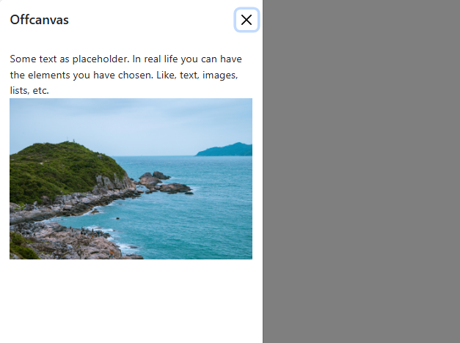

# **Classes and Attributes**

| **Class / Attribute** | **Meaning / Function** | **Possible Values / Notes** |
| --- | --- | --- |
| **offcanvas** | Enables Bootstrap Offcanvas component | Must be the main wrapper div |
| **offcanvas-start** | Offcanvas slides in from **left** | offcanvas-start, offcanvas-end, offcanvas-top, offcanvas-bottom |
| **id="offcanvasExample"** | Unique ID for linking trigger buttons | Any valid ID |
| **data-bs-toggle="offcanvas"** | Activates offcanvas behavior | Used on link/button |
| **href="#offcanvasExample"** | For <a> triggers; opens the selected Offcanvas | Must match Offcanvas ID |
| **data-bs-target="#offcanvasExample"** | Used on <button> triggers | Same effect as href |
| **offcanvas-header** | Header area of offcanvas | Contains title + close button |
| **offcanvas-title** | Styles the title inside offcanvas header | Any text inside it |
| **btn-close** | Bootstrap close button | Used with data-bs-dismiss="offcanvas" |
| **data-bs-dismiss="offcanvas"** | Closes the offcanvas when clicked | Works on close button |
| **offcanvas-body** | Scrollable content area | Holds text, images, links, etc. |
| **w-100** | Image width 100% | Any width utility like w-50, w-auto |
| **h-auto** | Keeps natural image height | Alternatives: h-25, h-50, h-100 |
| **btn btn-primary / btn-danger** | Styled Bootstrap buttons | btn-success, btn-dark, btn-secondary, etc. |

**Placement Classes**

| **Placement Class** | **Where Offcanvas Appears** |
| --- | --- |
| **offcanvas-start** | Slides in from **left** |
| **offcanvas-end** | Slides in from **right** |
| **offcanvas-top** | Slides in from **top** |
| **offcanvas-bottom** | Slides in from **bottom** |

**To see the effect of different placements, replace offcanvas-start with:  
offcanvas-end, offcanvas-top, or offcanvas-bottom.**